**Data types in Java**

Data types specify the different sizes and values that can be stored in the variable. There are two types of data types in Java:

1. **Primitive data types:** The primitive data types include boolean, char, byte, short, int, long, float and double.
2. **Non-primitive data types:** The non-primitive data types include [Classes](https://www.javatpoint.com/object-and-class-in-java), [Interfaces](https://www.javatpoint.com/interface-in-java), and [Arrays](https://www.javatpoint.com/array-in-java).

Java Primitive Data Types

In Java language, primitive data types are the building blocks of data manipulation. These are the most basic data types available in [Java language](https://www.javatpoint.com/java-tutorial).

There are 8 types of primitive data types:

* boolean data type
* byte data type
* char data type
* short data type
* int data type
* long data type
* float data type
* double data type

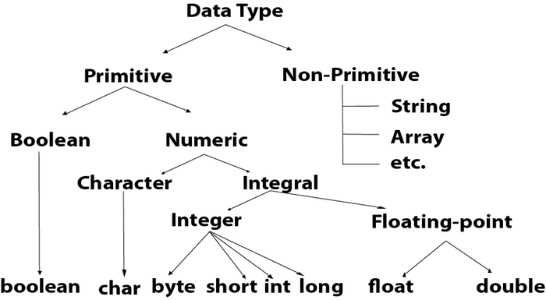

### Primitive Data Types

1. **byte**
   * Size: 8-bit
   * Range: -128 to 127
   * Example: byte b = 100;
2. **short**
   * Size: 16-bit
   * Range: -32,768 to 32,767
   * Example: short s = 10000;
3. **int**
   * Size: 32-bit
   * Range: -2^31 to 2^31 - 1 (-2,147,483,648 to 2,147,483,647)
   * Example: int i = 100000;
4. **long**
   * Size: 64-bit
   * Range: -2^63 to 2^63 - 1 (-9,223,372,036,854,775,808 to 9,223,372,036,854,775,807)
   * Example: long l = 100000L;
5. **float**
   * Size: 32-bit
   * Range: Approximately ±3.40282347E+38F (6-7 decimal digits precision)
   * Example: float f = 10.5f;
6. **double**
   * Size: 64-bit
   * Range: Approximately ±1.79769313486231570E+308 (15 decimal digits precision)
   * Example: double d = 10.5;
7. **char**
   * Size: 16-bit (single Unicode character)
   * Range: '\u0000' (0) to '\uffff' (65,535)
   * Example: char c = 'A';
8. **boolean**
   * Size: Not precisely defined (typically a single bit, but depends on the JVM)
   * Range: true or false
   * Example: boolean b = true;

### Reference Data Types

These include classes, interfaces, arrays, and enumerations. They do not have a fixed size as their size depends on the objects they refer to. The most common reference data type is String.

#### Example:

* String str = "Hello, World!";
* int[] arr = {1, 2, 3, 4, 5};